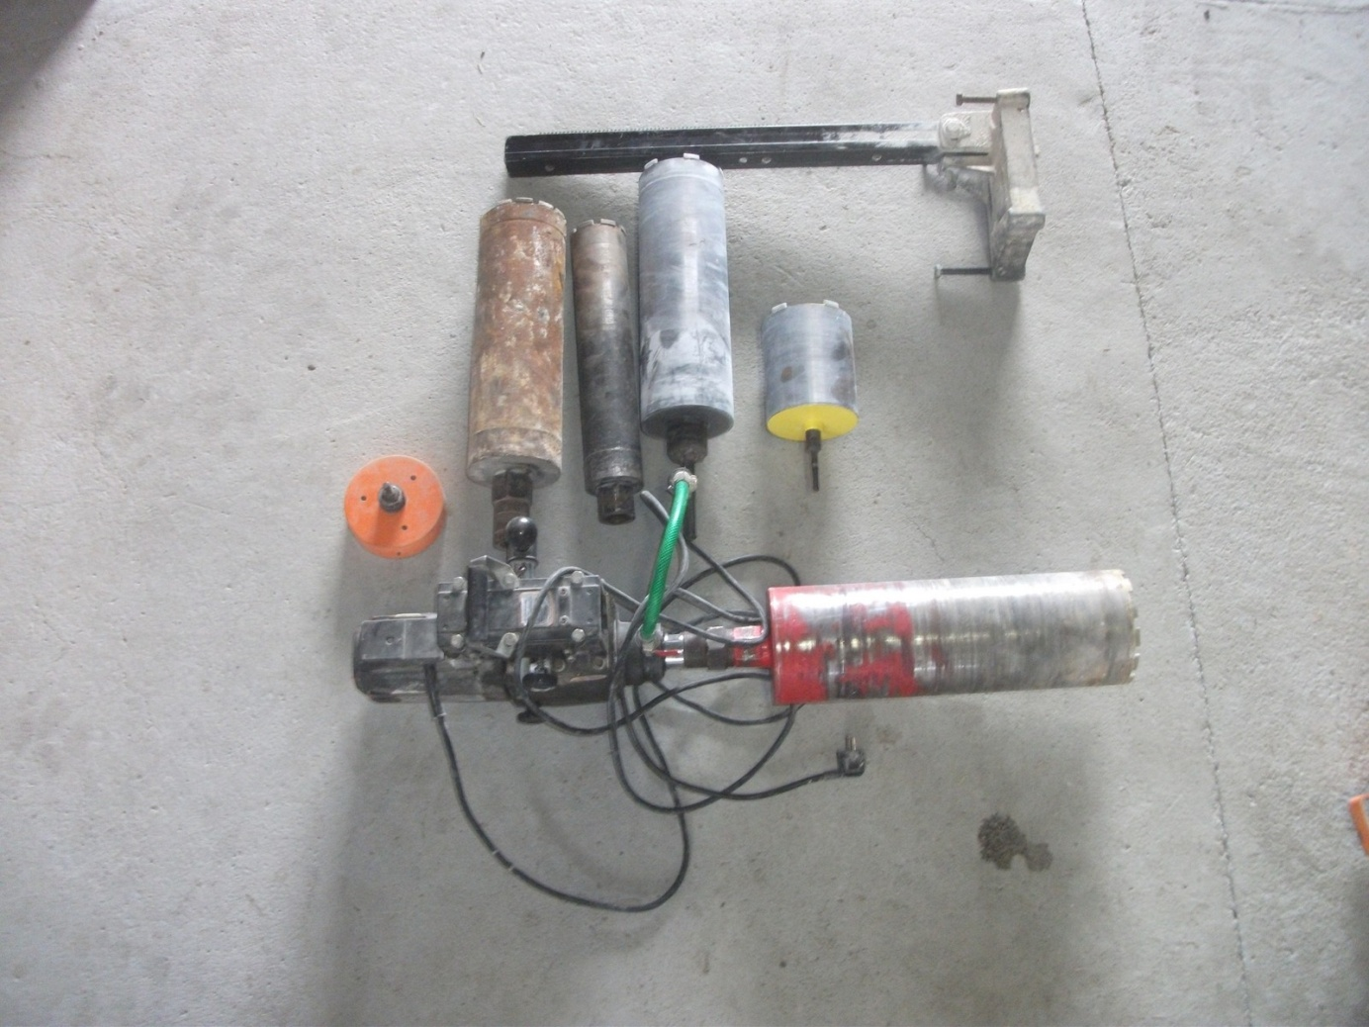

* **Motor**
* **Sojan**
* **Korunka ø 130 mm**
* **Korunka ø 80 mm**
* **Korunka ø 130 mm**
* **Korunka ø 130 mm**
* **Korunka ø 140 mm**
* **Korunka ø150 mm**